Event Proposal: [name of event]

Use this form to develop the event proposal which you will take to the Seneschal and Reeve, and to your group Council which must endorse the proposal. You can then cut-and-paste from this proposal into the Event Submission Form where your Seneschal provides formal approval. Delete the words in italics.

Start date |  | End date
[eg 12 Nov 2026] |  | [eg 13 Nov 2026]
(Note: attendees pay a kingdom levy for every day shown here, up to 5 days)

Timetable, if available (including setup time)

Location (including google-friendly address)
[disability access?]
[any special site requirements, eg on alcohol use?]
[any rules on cancellation fees or site bond?]

Event type
[one of: Feast, Tournament, Collegium, Crown Tournament, Coronation, Ball, War, Variety/Festival, Other]

Event description/details

Prices
Sample prices shown.
Adults: $xx
Children <18: $xx
Concession (pensioners, unemployed incl students): $xx
Offboard (BYO food): $XX
Non-SCA-members pay +$10 adults or +$5 minors [NZ is $2 adults only]
Camping: +$XX

Event website - optional

Steward legal name

Steward medieval name

Steward email address

Booking details, including closing date
[ideally, bookings@[yourgroup].lochac.sca.org, closing on ddmmyyyy.]

Summary of budget (required for Council endorsement, not for the submission form)
Cut and paste the budget summary from the Event Budget [add link here] template, with example below. Australian stewards are also required to complete a Risk Assessment [link].

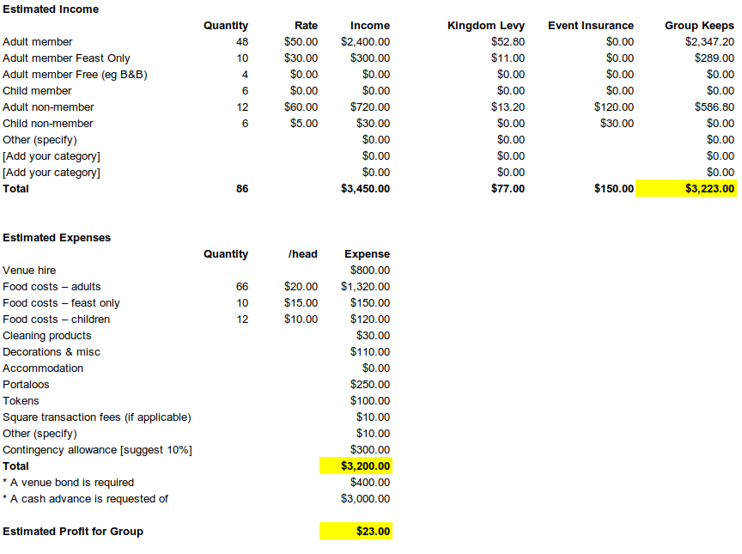

Ideally, the draft Event Proposal will be circulated before your group Council meeting, with the Agenda, and will be appended to the minutes of the meeting as a permanent record of what was endorsed.

Template by Master Cristoval, 29 Nov 2023
Please send suggested changes to rhysh@iinet.net.au

