Event Report: [name of event]

Use this form to report back to your Seneschal and Reeve after the event. Delete the words in italics.

Start date |  | End date
[eg 12 Nov 2026] |  | [eg 13 Nov 2026]

Steward legal name

Steward medieval name

Steward email address

Location
[any issues related to the location?]

Incidents
[if the report will be submitted to the group Council, or otherwise published, consider
de-identifying individuals]

Activities
A summary of activities and any highlights or challenges, eg. Tournament & Competition Victors, Peerage Ceremonies.

Recommendations
Any recommendations on how the event could be run better next time.

Key contributors
You may wish to draw the Seneschal’s attention to some key helpers.

Financial summary
Cut and paste the actuals summary from the Event Budget template, with example below.

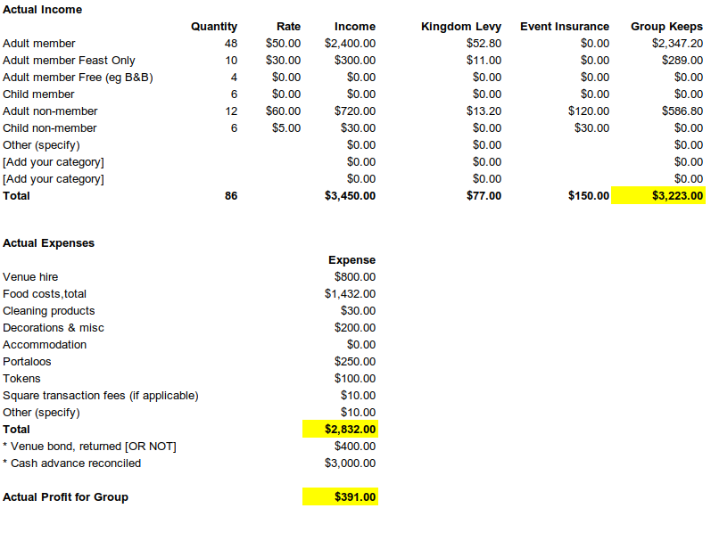

Subordinate reports received (provide to Steward and applicable group officers)
Y/N Marshal-in-charge report
Y/N Armoured combat report
Y/N Fencing report
Y/N Target archery report
Y/N Tournament report (listkeeper)
Y/N Chief Cook report
Y/N Bookings officer report
Y/N Gatekeeper report
Y/N Chirurgeon report
Y/N Constable report [particularly where overnight stays occurred]

The Reeve will ensure that this report goes into Dropbox.

Template by Master Cristoval, 29 Nov 2023
Please send suggested changes to rhysh@iinet.net.au

