Event Proposal: [name of event]

Use this form to develop the event proposal which you will take to the Seneschal and Reeve, and to your group Council which must endorse the proposal. You can then cut-and-paste from this proposal into the Event Submission Form where your Seneschal provides formal approval. Delete the words in italics.

Start date |  | End date
[eg 12 Nov 2026] |  | [eg 13 Nov 2026]
(Note: attendees pay a kingdom levy for every day shown here, up to 5 days)

Timetable, if available (including setup time)

Location (including google-friendly address)
[disability access?]
[any special site requirements, eg on alcohol use?]
[any rules on cancellation fees or site bond?]

Event type
[one of: Feast, Tournament, Collegium, Crown Tournament, Coronation, Ball, War, Variety/Festival, Other]

Event description/details

Prices
Sample prices shown.
Adults: $xx
Children <18: $xx
Concession (pensioners, unemployed incl students): $xx
Offboard (BYO food): $XX
Non-SCA-members pay +$10 adults or +$5 minors
Price rise $9 after bookings cutoff
Camping: +$XX

Event website - optional
[e.g. https://politarchopolis.lochac.sca.org/]

Steward legal name

Steward medieval name

Steward email address

Booking details, including closing date
[e.g. bookings@politarchopolis.lochac.sca.org, closing on ddmmyyyy.]

The rest of this form is not required for the online event submission form, but are helpful for baronial council to consider your proposal.

Event Crew
List any other stewarding team members here. Don’t assume that group officers will do this work; you must ask them. Not every event needs all these officers, so delete any that are not required or put “tba” where a person will be appointed but has not been decided yet.
Deputy Steward:
Bookings Officer:
Head Cook:
Event Constable:
Event Gatekeeper:
Event Herald:
Event Chirurgeon:
Royal Liaison:
Arts & Sciences Co-ordinator:
Dance Co-ordinator:
Entertainments Co-ordinator:
Children’s Activities:
Merchant Co-ordinator:
Event Hospitaller:
Setup Co-ordinator:
Packdown Co-ordinator:
Marshal in Charge:
Event Heavy Marshal:
Event Fencing Marshal:
Event Siege Marshal:
Event Archery Marshal:
Event Equestrian Marshal:
Youth Combat Marshal:
Event Listkeeper:

Summary of budget
Cut and paste the budget summary from the Event Budget template, with example below. If your event has no income or expenses, just put $0 here and don’t worry about doing the spreadsheet.

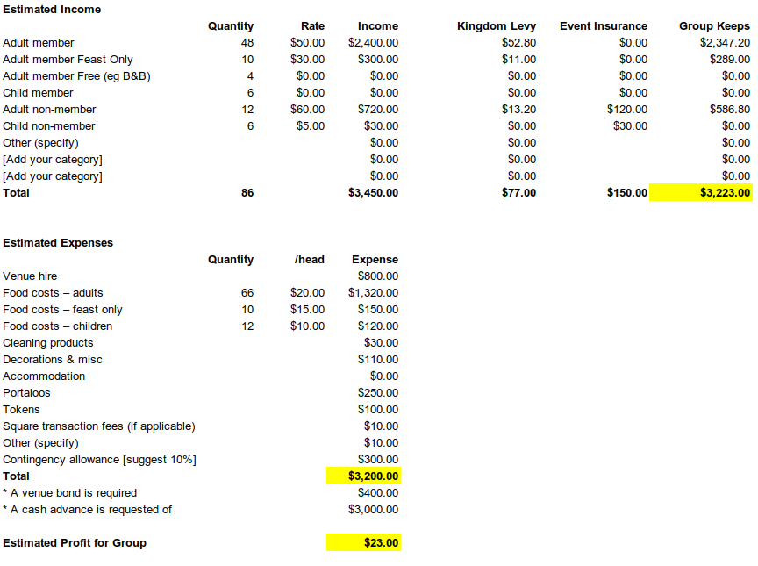

Australian stewards are also required to complete a Risk Assessment. The template is pretty good for normal events, so don’t panic. But do read it, and if there’s something noteworthy that needs calling out for your event then please add it.

Ideally, the draft Event Proposal will be circulated before your group Council meeting, with the Agenda, and will be appended to the minutes of the meeting as a permanent record of what was endorsed.

Template by Master Cristoval, 29 Nov 2023
Please send suggested changes to reeve@politarchopolis.lochac.sca.org
Last updated 8 Dec 2025

